|  |  |  |
| --- | --- | --- |
|  |  | **School Newsletter 8th August 2023 2023** |
| **Ltyentye Apurte Catholic School**  Church Street, Santa Teresa, PMB 221, Via Alice Springs, NT, 0872.  Tel: (08) 8956 0937 email: robert.dreise@nt.catholic.edu.au |

Dear Families,

**NAIDOC Celebrations**

I would like to extend my gratitude and appreciation to our Catholic Aboriginal Leadership Team (CALT) for organising a terrific NAIDOC celebration! Thecla, Delphina and Renee organised a day that promoted Arrernte culture and united our community. Thanks also to the different community groups and volunteers who joined together to make the day a wonderful event. Students were involved in making bush medicine, painting Aboriginal flags on mini canvases, painting boomerangs, designing bead jewellery, tie dying t-shirts, face painting, and decorating cupcakes. (And of course, eating them.) A BIG thank you to our Arrernte men who prepared kangaroo tail and roast vegetables on the fire. Salads and sausages prepared by chef Tony added to making our lunch very delicious. Appreciation also goes to those volunteers who made the yummy damper. Thanks also to our local council for preparing the area and for setting up tents. A final thanks to our LACS staff for your continued efforts in making such days run smoothly! The students at Ltyentye Apurte are so lucky to have such wonderful teachers and assistant teachers.

**Lourdes Hill Visit**

Staff and students from Lourdes Hill Brisbane recently visited our school and thoroughly enjoyed their visit. They were fortunate enough to be involved in our NAIDOC celebrations. The day gave the visiting students the opportunity to recognise and celebrate the history, culture, and achievements of Arrernte culture.

**RSAS BBQ**

On behalf of the staff and students I would like to thank Brother Mark and the RSAS team for providing a BBQ last week. The BBQ was organised to promote attendance and was followed by a novelty sport carnival on the oval. Every day at school counts so parents, carers and grandparents are encouraged to make sure that students attend school every day.

**FAITH FOCUS**

|  |  |
| --- | --- |
| Pentecost Sunday Holy Spirit 2543301 Vector Art at Vecteezy | In our Gospel for the Feast of the Transfiguration, Peter, James, and John journey with Jesus up a high mountain where they are given a glimpse of glory.  For a brief time, they see with clarity who Jesus is and hear a voice telling them, “This is my beloved Son ... listen to him.”  We can only imagine what they felt in that moment of beauty. Our lives are full of glimpses of glory – a helping hand, a loving smile, a beautiful sunrise or sunset, a kind deed.  All ways God’s glory is revealed to us.  Funeral Mass for Kwemwentyaye Turner will be on Thursday 17th August 10:00am at the Telegraph Station Alice Springs. The CALT team has requested that Ltyentye Apurte Catholic School be closed on that day. We ask for God’ mercy and grace for those who have passed away as they begin their journey into eternal life. We also pray for those who are left behind, that they may find comfort and hope in God’s presence. |

**Welcome Bishop Charles**

|  |  |
| --- | --- |
|  | Bishop Charles will be visiting Ltyentye Apurte this week. He will say mass on Thursday at 11:30am before meeting the Confirmation candidates for a final sacrament preparation. Bishop Charles will assist Father Ollie on Saturday evening for the Confirmation ceremony at 6pm. |
|  | **Tell Them from Me Survey**  Staff, students, and parents will have the opportunity to complete a survey during the next two weeks to give feedback about our school. Your valuable feedback will give staff the opportunity to improve our school. |



Please note the time change for Confirmation. The ceremony will now be held at 6pm.

Please join us.

May God bless our students and families. Have a great week, everyone!

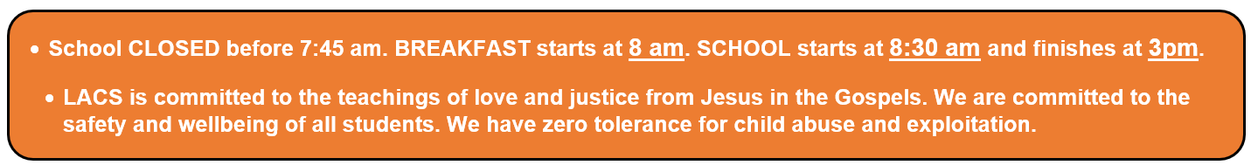

Mr. D

A / Principal

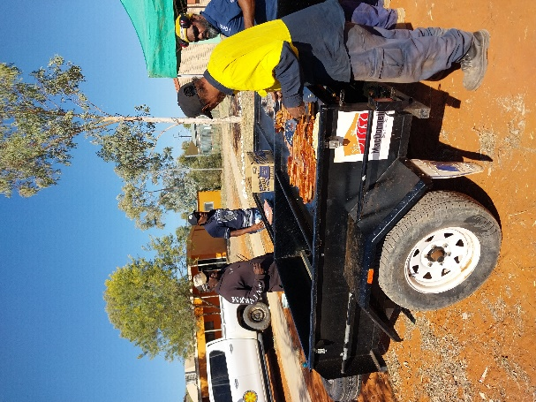

**NAIDOC**

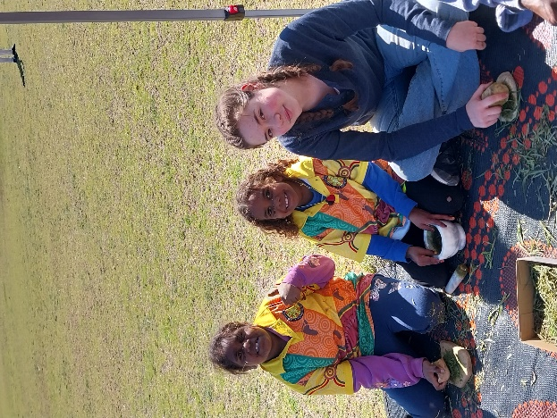

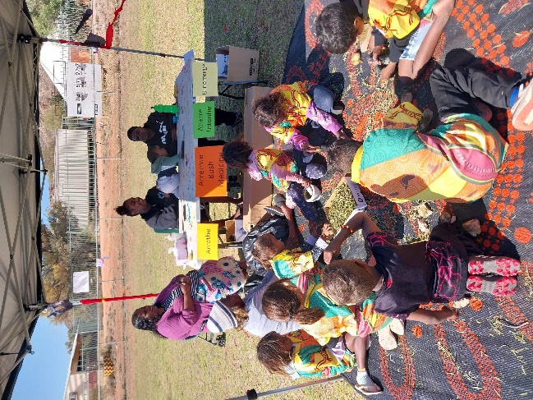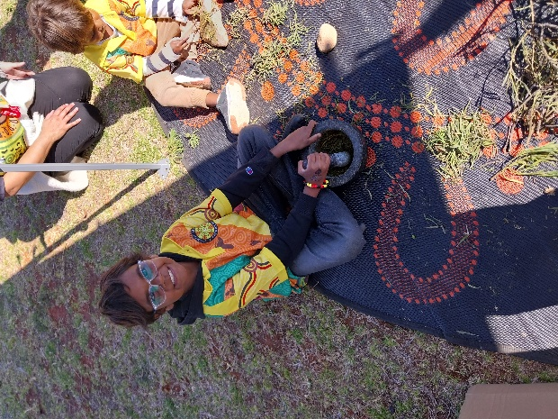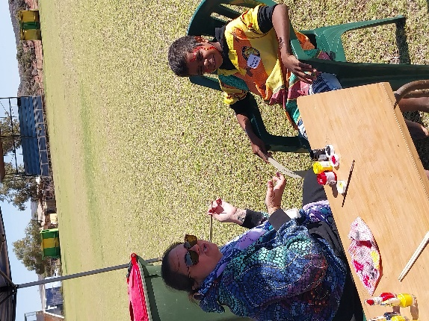

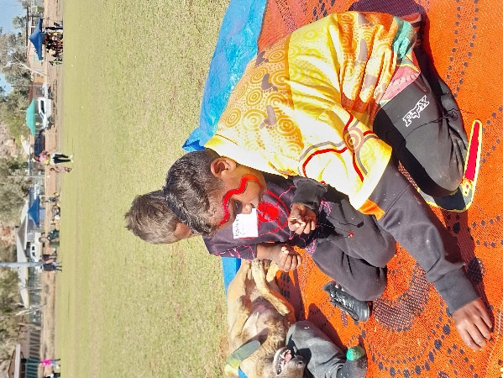

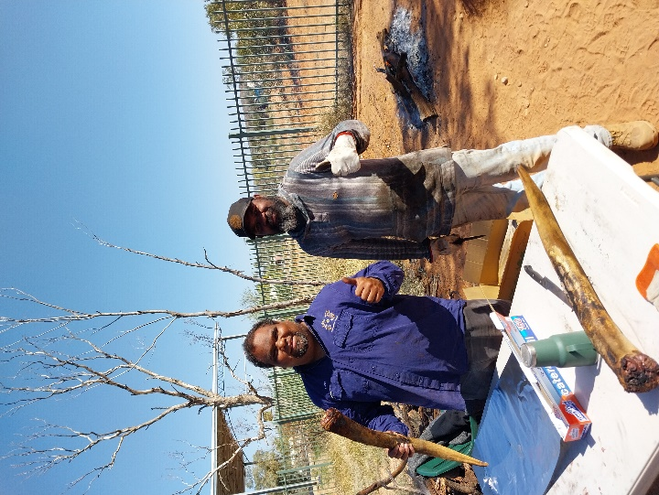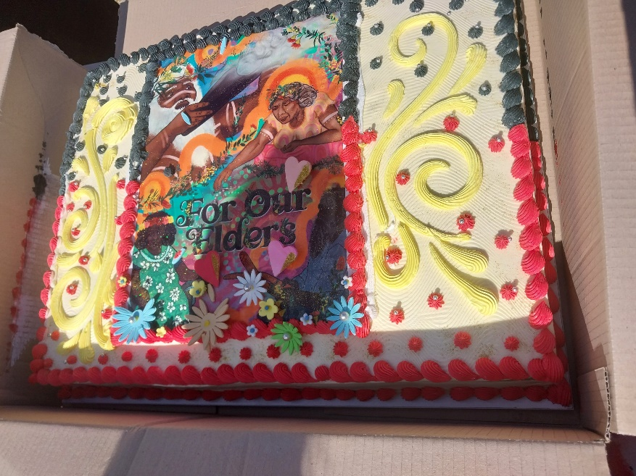

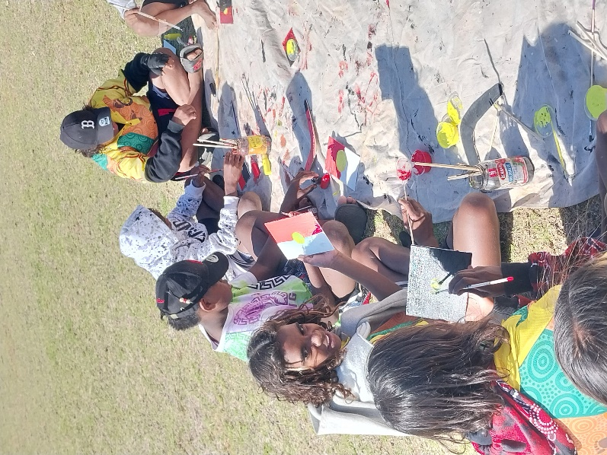

**NAIDOC**

**Celebrations**

